*The Wait May Is Over*

*Joshua E. Powell*

University of North Alabama

*2019/04/04*

Abstract

Recently, I’ve been to Chick-fil-a near where I live, and nearly waited 30 minutes to get my food and to my surprise they’d gotten my order wrong. This happens occasionally at this location. There weren’t that many customers. I had noticed the Chick-fil-a on Cox Creek seems to struggle with orders as more customers walk through the door. I talked to the Manager and she said, “We strive to meet the standard goal of four minutes and sixteen seconds which is the standard set by the company, but sometimes that’s just isn’t the case (2019). Watching the Chick-Fi- A in the GUC operate everyday has given me an idea on how the restaurant on Cox Creek can reduce customer’s wait time, increase customer’s satisfaction, and reduce stress for both workers and customers by investing in smart kiosks as well. In this paper, I will talk about how the Chick-fil-a on Cox Creek, and any other location, can benefit from investing in a smart kiosk as well.

**INTRODUCTION**

Have you ever been to Chick-fil-a and thought to yourself, “Wow the lines are long”! **There is no doubt that Chick-fil-a is one of the most successful food chains in America.** Chick-fil-a is among one the most popular fast food chains and makes 3.1 million a day just from one store (LIFE, 2015).**Whenever I go to the nearest Chick-fil-a by home, I realized I wait a unreasonable amount of time and occasionally my order wrong. Compared to when I go to the Chick-fil-a on campus, I am served relatively faster then eating at the one near my house and rarely has been wrong. Honestly, I prefer driving the extra five minutes to eat at the Chick-fil-a on campus, then the one that’s five minutes away from my house on Cox Creek. I started thinking why I prefer the Chick-fil-a on campus over the one closer to home. Well I’ve notice that the restaurant on campus has a kiosk-ordering service and students have the option to wait in-line to order. Because of the technological advantage the restaurant on campus has, they can complete 20 students’ orders compared to the restaurant on Cox Creek that struggles to complete the orders of 16 customers. When the number of customers reaches a certain point then wait time increase resulting in more room for human error and buildup of stress. I still remember the stress I’ve felt when I worked at Taco Bell and orders came flying in; I didn’t care how the order came out as long as I got it out within the recommended time. This led me to believe that the Chick-fil-a on Cox Creek can increase customer satisfaction and decrease wait-time, which will result in a major increase in revenue.**

**STATEMENT OF PROBLEM**

**Problem**

**The Chick-fil-a located on Cox Creek struggles with service performance as the number of customers increase. Granted, customer service is not affected, and, remain genuine and hospitable with every customer. However, I have seen customers leave or ask for a refund because they’ve felt that they had waited to long to be served. A month prior, I visited both locations to record how long the ordering process was for a certain number of customers. The data does not account for how complex an order is, online or call-in orders, or other factors that may not be mentioned.**

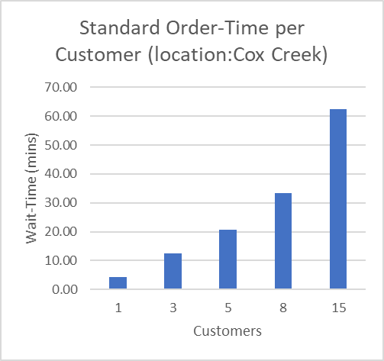

**This graph illustrates how long the ordering process takes per customer based on the company’s standard time of 4 minutes and 16 seconds (Chick-fil-a). As the number of customers increase the time a customer has to wait on their order increase as well.**

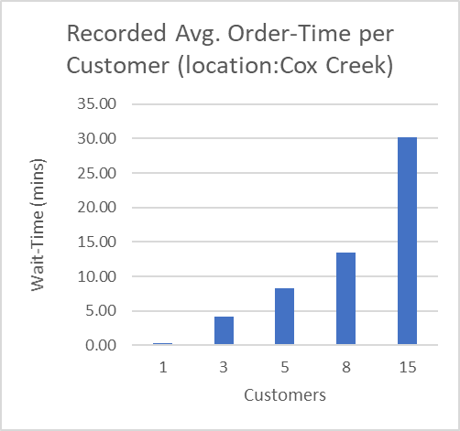

**This graph illustrates the average time I’ve recorded each customer spent going through the ordering process. Customer’s orders were done pretty fast. As the number of customers increased, the wait-time increased as well. However, it is lower than the wait-time of the company’s standard goal. For this reason, the standard time doesn’t account for their employees rushing the process, such as the employees did as the restaurant get busier and busier.**

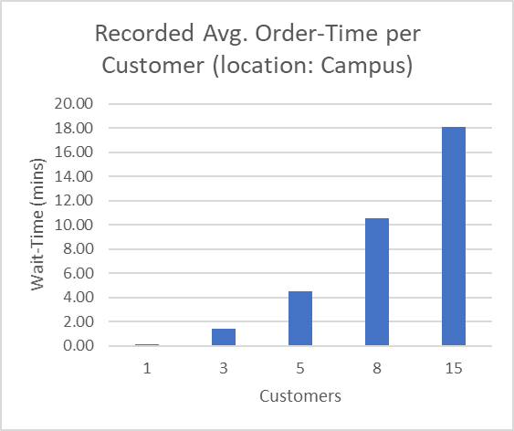

**This graph illustrates the average wait-time a customer spends at the Chick-fil-a on campus. The campus location offers customers the options to stand in-line to order or use their kiosk center. Because of this advantage the wait-time a customer experienced was reduced drastically. They could be understaffed and still out perform the standard time and Cox Creek.**

**Impact of Problem/Sub-problems**

***Clearly state the impact and the extent of the problem and/or sub-problems on the organization/customer, as well as the purpose of the paper as an attempt to solve the problem you have identified.***

**PROBLEM ANALYSIS**

**Relevant Social Factors**

**There are not social factors that led to this problem. The issue is improving the service performance of the Chick-fil-a on Cox Creek by implementing a technological advantage, the same, as the kiosk that is used by the Chick-fil-a in the GUC.**

**Relevant Political Factors**

**There are no political factors that impacted this issue. This issue has no concern with politics or government.**

**Relevant Economic Factors**

**The economy has no impact on the problem I’m trying to solve.**

**Relevant Legal Factors**

**If Chick-fil-a were to implement my idea of investing in kiosks to improve the ordering process, then there are some legal factors they’ll have to consider. First, the restaurant would have to look into a buyer. What ever company the kiosks are purchased from they will have owner’s rights over the device. So, if the kiosk were to malfunction and a customer gets hurt Chick-fil-a will not be the ones to face charges. Secondly, Chick-fil-a will have to be aware of intellectual rights if they decide to purchase an operating software so customers can order. Chick-fil-a could be sued if they were to have one of their IT employees to make any changes to the software, because that would be infringing on a patent, trademark, etc.**

**Possible Causes of the Problem**

**There are two flaws I noticed in Chick-fil-a’s ordering process. First, being understaffed affects how quickly an order is taken then given to a customer. I learned that there may be three employees taking orders during the busiest times of day. Lines would be moving fast, but if an employee leaves to go to the restroom lines get backed up. Another flaw is that Chick-fil-a doesn’t account for complex orders in their standard model. Customers have the option to customize any order of their choosing, because of this an employee may spend extra time with this customer to make sure their order is right.**

**Issues Due to Problem**

**The Chick-fil-a on Cox Creek struggles with keeping the time of orders completed at the standard time set by the company or lower. When talking to the manager she confirmed that they don’t always meet the standard time of four minutes. Also, customers aren’t getting what they’ve paid for, sometimes there’s a mistake in their order. I can assure you that my order was wrong on three occasion when I ate at Cox Creek. Two weeks ago, I can recall how busy it was when I had gone to do some research and how the lady at the register kind of rushed me through the process of taking my order. A customer said, “The food’s great! I just hate waiting 25 minutes for 1 chicken sandwich and an order of large fries”, as I stood next to here in-line. At the time I counted only twelve customers in-line, not including drive-thru and people who already ordered. While observing the employees you can tell how stress they were getting as they glanced at the herd of people coming into the store, then back at the person in front of them. Most people tend to make mistakes when they’re working in a high stressed environment. A total of 48.8% of mistakes can be explained by stress, repetition, fatigue and work environment (ResearchGate, 2014).**

**PROBLEM SOLUTIONS**

**Potential Solution #1**

**A kiosk center should be placed in the Chick-fil-a on Cox Creek. It should operate in the same way as the one available in the GUC. Customers should also be able to connect the Chick-fil-a app on their phone to the kiosk. Customers can order through the app, find and confirm their order at the kiosk, and then not have to wait in-line just grab and go. The kiosks center will also have an employee to assist customers and applications for the impaired such as voice-command, brail, and pictures.**

**Potential Solution #2**

**DIY’s, do it yourself, is trending now-a-days. If Chick-fil-a wanted to hop on a new fab, then they could invest in a DIY assembly line. This area will have Chick-fil-a’s most bought and popular food items. A customer can walk in, grab what they want, place the food on either a tray or bag them, and finally pay for their food. Customer’s can decide at their own pace. Although it’s limited, it can meet the needs of a typical customer who wants just a sandwich, fry, and drink. Larger orders or customized orders can be taken at the regular registers.**

**Merits of Potential Solution #1**

**This allows customers to order from anywhere on the go. Partnered with the app, it makes it easier for customers to customize, order, and pay for their food; and pick it up anytime they please. This can improve the wait-time by shortening four minutes in half, because the customer can send in the order and the employees sees the order, then prepares it easily. Having this technological advantage can reduce stress for both the customers and employees. No longer employees have to rush an order or struggle with trying to comprehend the speech of a customer.**

**Merits of Potential Solution #2**

**This benefits the customers that are usually in a rush. Customers that are own their way to school, work, or break will benefit from this the most. Although customization is limited, customers can move at their own pace and go in any order. This plan will satisfy your customer’s basic needs.**

**Proposed Solution**

**There is no doubt that the Chick-fil-a on Cox Creek would have the most success with the kiosk center. They are always busy because the road they’re on has very high traffic. The lines usually get really long, nearly backing back into the Florence Mall’s parking lot. Along with the app, it can improve their service ten-fold; making it easier and faster to satisfy their loyal customer. Customers will have the leisure to order anywhere and pick up at any time.**

**Proposed Solution Justification/Benefits**

***Clearly state the reasons that you proposed this solution, including all of the potential benefits.***

**Proposed Solution Implementation Plan**

***Clearly state a detailed, step by step implementation plan for your proposed solution.***

**Proposed Solution Feasibility Analysis**

***Clearly state the feasibility of this solution for the company.***

***______________________________________________________________________________***

**References**

# References

*Chick-fil-a*. (n.d.). Retrieved from https://www.chick-fil-a.com/

*Effects of Stress, Repetition, Fatigue and Work Environment on Human Error in Manufacturing Industries*. (2014, September ). Retrieved from ResearchGate: https://www.researchgate.net/publication/266025022_Effects_of_Stress_Repetition_Fatigue_and_Work_Environment_on_Human_Error_in_Manufacturing_Industries

Strutner, S. (2015, October 05). *LIFE*. Retrieved from The Crazy Way Chick-fil-A Beats Other Fast-Food Chains: https://www.huffpost.com/entry/chickfila-closed-on-sunday_n_560ea151e4b076812701aab6